Using S3 Batch Operations

**Enable S3 Inventory on Your Bucket:**

* **Go to Amazon S3 → Select Your Bucket → Management tab.**
* **Click on Create Inventory Configuration.**
* **Provide the necessary details and choose an output format csv**

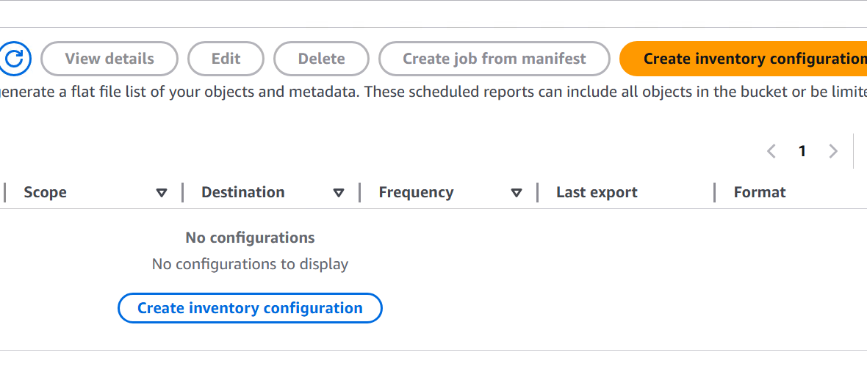

* Provide details

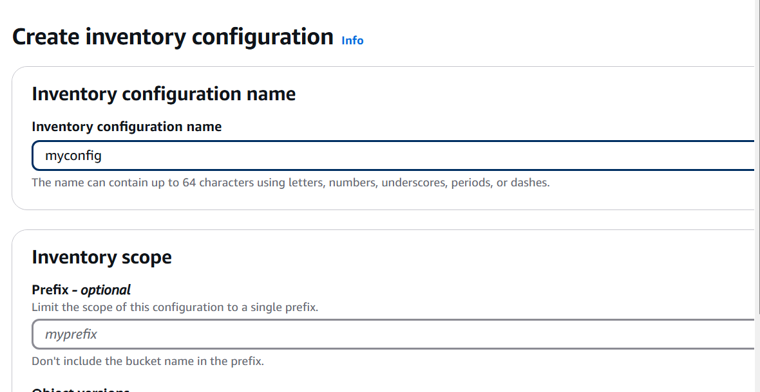

Output format

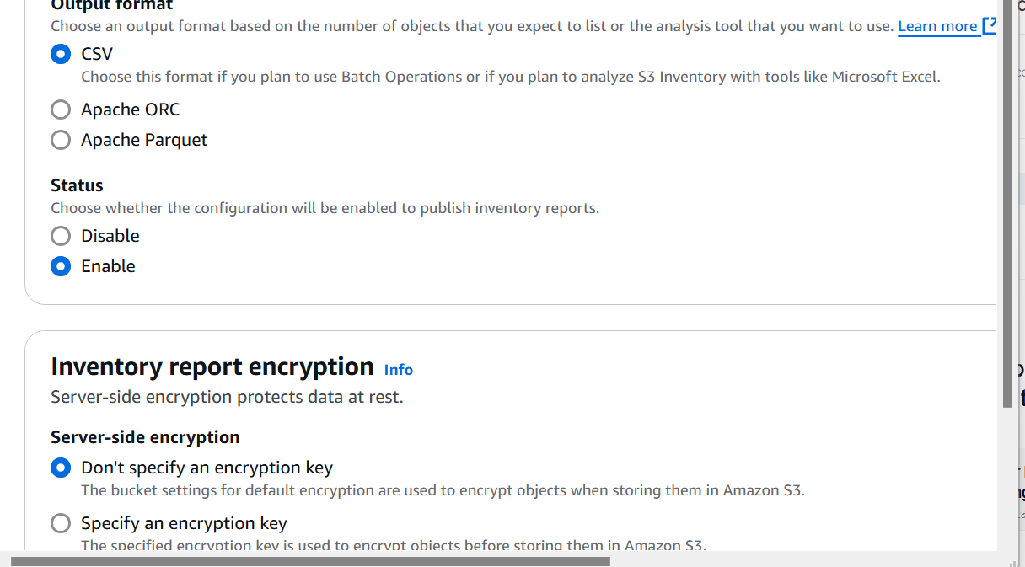

• **Go to AWS Console → S3 → Batch Operations.**

• **Create a New Batch Job:**

* Select the **inventory file** from Step 1.
* Choose the operation, e.g., **Restore** (for restoring Glacier-archived objects).
* Set the **Number of Days** to keep objects restored.
* Choose **Standard** or **Bulk** retrieval.

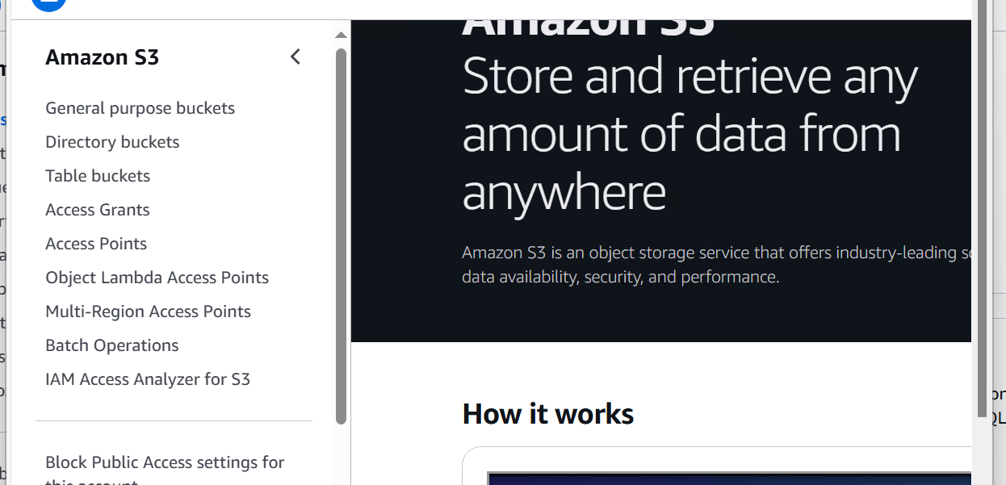

**Create a new Batch Job**:

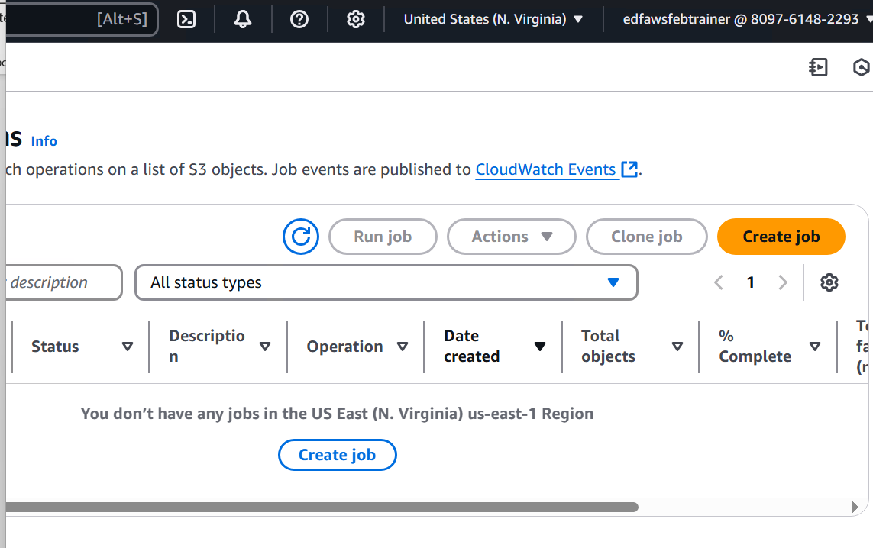

* **Select the inventory file** from Step 1.

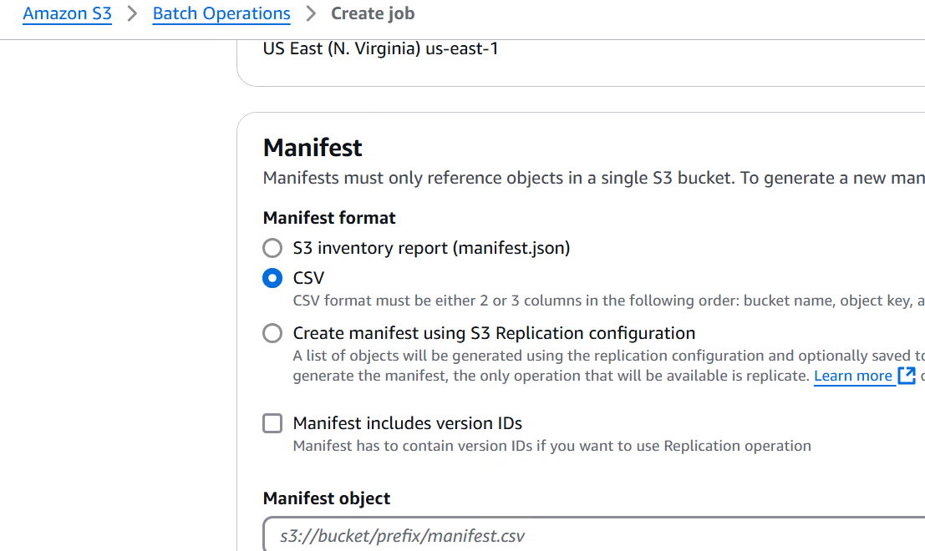

* **Choose "Restore" operation** (for restoring Glacier-archived objects).
* Set **Number of Days** to keep objects restored.
* Choose **Standard or Bulk retrieval**.

**Run the batch job** and AWS will restore the objects asynchronously.